Q- FACTOR OF A CAVITY

Objective: Measurement of the Q-Factor of a Cavity.

List of Equipment
- Microwave source with square wave modulation
- Isolator
- Variable attenuator
- Slotted line
- Tunable detector
- VSWR meter.

Theory
The microwave cavities are basically of two types:
- Transmission type
- Absorption type

The transmission type cavity transmits maximum power at resonant frequency and absorption type absorbs the power at the resonant frequency. Cavities are used both as circuit elements and as measuring instruments.
The Q-factor of a cavity has the same meaning as the Q of a resonant circuit lower frequency. It is defined as
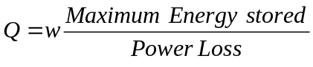
Energy stored in the cavity depends on the volume, and the power loss depends on the losses in the conducting walls of the cavity. Approximate value of the Q of the cavity is

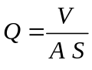
V = Volume of the cavity
A = Surface area
S = Skin depth
The intrinsic or unloaded Q is greater than the total or loaded 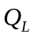which includes the effect of coupling mechanism. The loaded of a cavity may be measured very simply by observing the shape of its resonance curve as a function of frequency. The of the cavity is determined from
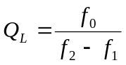
f₀ Resonant frequency
f₁ & f₂ the 3 dB points

Procedure

Microwave source with square wave modulation

Isolator
Variable Attenuator
Directional
Coupler

Cavity

Detector

VSWR
meter
Tunable Detector

VSWR
meter

Fig 1. Experimental arrangement for measurement of Q factor of a Cavity

- Set the microwave bench as shown in the figure.
- Set the cavity of any position. Set the source frequency output shows a dip if it is a absorption type of vice-versa.
- Keeping the input power to the cavity constant (by using variable attenuator, if necessary), measure the frequencies 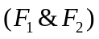of signal source setting where the output power changes by 3 dB from the resonant frequency value.
- The graph between frequency and power output may also be drawn.
- Calculate the value of Q using the given formula. Repeat the different cavity settings.

Discussions
- Does the Q-depend on the coupling of the cavity?
- What are the different types of coupling to cavity?
- Give the equivalent circuit of a cavity at the resonant frequency, and also below and above the resonance frequency.
- What are the dimensions of rectangular, cylindrical & coaxial cavity to achieve maximum Q?
- Where the fixed and variable cavities used?

References
- S. Ramo, J.R. Whinney and I. VanDuzer, Fields and Waves in Communication Electronics, Third Edition, John Wiley & Sons, 1994.
- E.L. Ginzton: Microwave Measurements, McGraw-Hill Book Company, Inc. New York, 1957.
- Annapurna Das, Sisir K Das, Microwave Engineering, McGraw-Hill International Edition, Singapore, 2000.
- C. G. Montgomery, Techniques of Microwave Measurements, McGraw-Hill, New York, 1947.

